Press release 18SH17  
Innovation and Technology Days 18-20/05/2017 March 2017

**Version 1, 17/03/2017**

Please, check text, images and image captions. Indicate any changes made ("track changes" function in Word). Mark your selection.

**☐** Release for publication

**☐** Change and new template

**☐** After change, release for publication

Date + signature

SHW Werkzeugmaschinen would like to invite you to its "Innovation and Technology Days" trade show, being held May 18-20

**Version 2, 22/03/2017**

Please, check text, images and image captions. Indicate any changes made ("track changes" function in Word). Mark your selection.

**☐** Release for publication

**☐** Change and new template

**☐** After change, release for publication

Date + signature

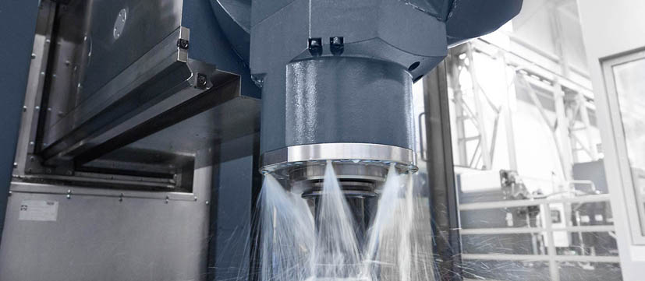

Hands-on machinery at   
SHW Werkzeugmaschinen

Contact and information:

SHW Werkzeugmaschinen GmbH  
Danny Basic  
Alte Schmiede 1  
D-73433 Aalen-Wasseralfingen, Germany  
Tel. +49 7361 – 5578 813  
danny.basic[at]shw-wm.de  
www.shw-wm.de

*Text + Images under www.pressearbeit.org*

(Aalen) Under the motto "Hands-on machinery," SHW Werkzeugmaschi­nen (SHW WM) will be holding the "Innovation and Technology Days 2017" exhibition, May 18 - 20. At their location in Aalen-Wasseralfingen, the leading technology company SHW WM will be presenting their latest innovations in large part machining.­­ Among the technologies on display are the new SHW WM data glasses, the Visual Setup Control Tool and the SHW WM UniSc@n diagnostic programme.­ The exhibition will also be accompanied by expert presentations on the latest information on everything from the complete machine space processing to business administration.­ Plus, there will be machines to see live in action.

"When we think engineering, we think user-friendly operation. Because we understand the needs of both the contract manufacturer and the series supplier," asserts Martin Rathbeb, Technical Director at SHW Werkzeugmaschinen. From May 18-20, guests are invited to see just what he means live in Aalen, Germany. At the Innovation and Technology Days, large part machining expert SHW WM lets you experience "hands-on machinery".­ In addition to seeing current machines in operation, guests will also have the opportunity to see SHW WM's latest engineering innovations. This includes several developments for increasing machine productivity.

Through the glasses instead of traffic

With our new Augmented Reality glasses, SHW WM literally offers you a glimpse into the future of personal communication between service representative, application technician and machine operator.­­ The operator puts on the glasses, and the SHW WM expert can actually observe the situation in real time as they provide assistance, practically seeing it through the eyes of the operator. This eliminates the need for field service in most service and support situations, allowing customers to get their machines up and running again faster. And the possibilities go far beyond two-way communication with live imaging and audio between user and service technician. The glasses can also be used to transmit and even edit data sheets, images or live screenshots. Pointers and PC cursors can also be loaded.

With the new Visual Setup Control, SHW WM makes it possible to use a camera to review the clamping set-up of large work pieces in 2D or 3D with position detection.­ This practical and inexpensive tool particularly helps reduce tooling times and ensure process reliability for contract manufacturers who perform frequent clamping operations.

UniSc@n diagnostic tool for predictive maintenance

SHW WM UniSc@n creates a "fingerprint" for each machine before it is shipped out. The diagnostics and protection programme monitors the status of the machine's mechanical components like a condition monitoring system. A condition check feature which can be accessed at any time compares the current condition with the condition on delivery, allowing for efficient, predictable and condition-based maintenance. This makes it possible to detect wear on roller bearings, linear axes and other components early on and respond as necessary. With response times of under 1 ms, UniSc@n also helps you avoid having to deal with crashes.

If you wish to attend the SHW Innovations and Technology Days, please register by calling (+49) 07361 – 5578 801 or sending an email to messe@shw-wm.de.

*423 words, 3,248 characters   
On publication, please send two copies to SUXES*

*Text and images also available at www.pressearbeit.org*

# ((Company Info SHW Werkzeugmaschinen GmbH))

# A young company with an ancient tradition

SHW Werkzeugmaschinen GmbH is one of the world's leading manufacturers of machine tools for the machining of large-sized parts. The machining centres with their large travel distances are used for production of parts, which must have a high degree of precision in spite of their huge size, for machinery, mould and plant construction, turbine and tool manufacture, or for the aircraft industry.

Customers include both contract manufacturers and suppliers of series production parts. SHW Werkzeugmaschinen understands their needs first-hand, thanks to our wholly owned subsidiary SHW Bearbeitungstechnik - a classical contract manufacturer - as well as through customers who order specially configured machines for specific parts.

What started as a young and innovative company in Aalen-Wasseralfingen in 1999, can actually look back on a tradition in industrial technology which dates back to 1365. Consistent growth and a commitment to the Swabian location, with some 200 highly qualified and quality-conscious employees, have recently led to an annual turnover of around 63 million Euro. A presence in 45 countries ensures customer proximity worldwide.

Image directory SHW WM, in-house exhibition 2017  
Access text and images with 2 clicks at www.pressearbeit.org.

|  |
| --- |
| Server_Daten:Alle:01 KUNDEN:  INDUSTRIE-D:10715 SHW WZM:01 SHW PRESSEARBEIT:18 SH_HAUSMESSE2017:BILDER THUMBS:18-001 SH_Maschine.jpg  Image no. 18-01 SH\_Maschine.jpg  The Innovation and Technology Days 2017 trade show will be held at SHW Werkzeugmaschinen from May 18- |